Comparison between a Photovoltaic-Thermoelectric Hybrid System with and without Solar Concentrator

Mohamed Mejdal1, a), Mohamed Nfaoui2, b), Sanaa Hayani Mounir1, c)

1 University of Moulay Slimane, Polydisciplinary Faculty of Khouribga, Energétique, Matériaux, Atomique et Fusion d’information (EMAFI), BP. 145, Khouribga, Morocco

2 University of Moulay Slimane, Polydisciplinary Faculty of Khouribga, Laboratory of Nanosciences and Modeling, BP. 145, Khouribga, Morocco

a)Corresponding author: mejdal.e@gmail.com b)nfaoui.smp@gmail.com

c) sanaachikhi@yahoo.com

**Abstract.** This study aims to increase the solar energy conversion into electrical energy by integrating two different systems, namely the photovoltaic system PV and the thermoelectric generator TEG. The thermoelectric generator will convert by Seebeck effect the thermal energy produced by the photovoltaic panel which will add additional electrical power to the overall power. A comparison between the hybrid system with solar concentrator and without solar concentrator was carried out. The contribution of the thermoelectric generator in both types of the hybrid system is evaluated. The study also focused on the impact of climate factors, which are solar irradiation, ambient temperature and wend speed, on the performance of both hybrid systems. For this purpose a mathematical model that takes into account the environmental factors and thermal and optical losses in the hybrid system has been developed. Six energy balance equations were obtained with six surface temperatures. The resolution of the six nonlinear equations is carried out by applying the Newthon-Raphson method. Results showed that the contribution of the thermoelectric generator in the hybrid system with solar concentrator is large compared to the hybrid system without solar concentrator which shows a small improvement. The power generated by the hybrid system with a solar concentrator is very large with respect to a photovoltaic panel. While the power of hybrid system without solar concentrator shows only a slight improvement. Results encourage the use of a solar concentrator in this hybrid system for better solar energy conversion.

# Keywords: Photovoltaic; Thermoelectric; Hybrid; Solar; Concentrator; Newthon-Raphson.

# introduction

The major constraint of a photovoltaic (PV) cell efficiency is the increase in its temperature due to the conversion of a large proportion of solar irradiations into heat [1]. In order to improve the conversion of solar energy to electric power by the PV cell, a number of solutions have been proposed, including the use of cooling systems [2] and the integration of phase change materials. Another approach is to hybridize the PV cell with another electric generator [3].

This study aims to increase the solar energy conversion into electrical energy by integrating the photovoltaic system with the thermoelectric generator TEG. A comparison between the hybrid system with and without solar concentrator was carried out.

In the literature, mathematical models are often simplified and do not take into account some considerations. Van Sark [4] evaluated the feasibility of the hybrid system. However, he considered in his model that the conductivity, the resistivity and the Seebeck coefficients are independent of the temperature. Jian and Liao [5] examined the parameters influencing the PV-TEG hybrid system. They only studied the effect of solar irradiation but the ambient temperature and the wind speed were not studied. Also, the Thomson effect is not included.

The study focused on the impact of climate factors, which are solar irradiation, ambient, temperature and wend speed, on the performance of both hybrid systems.  For this purpose a mathematical model that takes into account the environmental factors and thermal and optical losses in the hybrid system has been developed.

# MATHEMATICAL MODEL

Figure 1 presents a simplified description of the studied PV-TEG hybrid system.

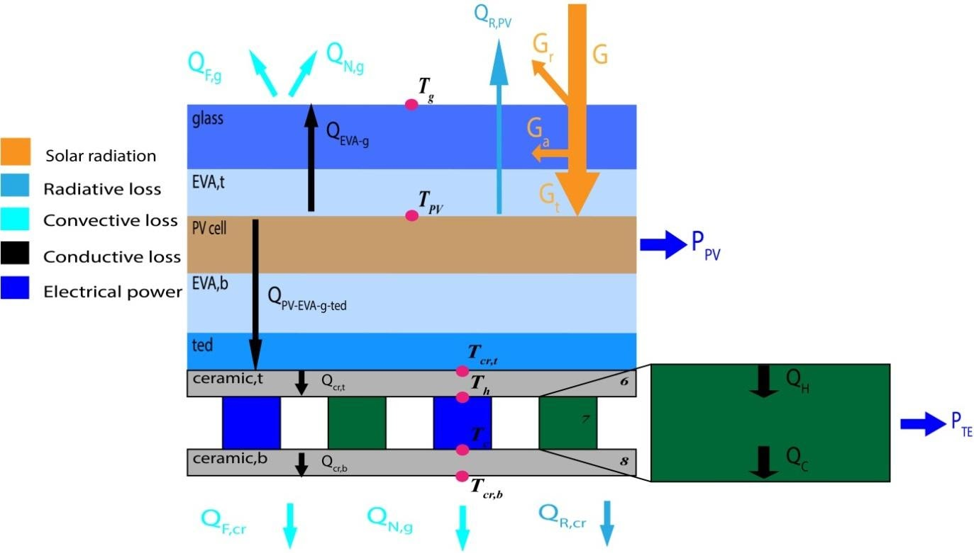

1. **The layers constituting the PV-TEG hybrid system.**

**Figure 1.** The layers constituting the PV-TEG hybrid system.

According to figure 1, six energy balance equations was obtained with six surface temperature, which are the temperature of the top glass surface, the temperature of the top crystalline cell,  the temperature of the top ceramic hot side surface and the temperature of the bottom ceramic cold side surface. The determination of these temperatures makes it possible to calculate the power generated by the studied system. The resolution of this system with six nonlinear equations is carried out by applying the Newthon-Raphson method.

By applying the energy balance to the upper surface of the glass, we obtain the first equation:

$$0=GaA_{PV}+Q_{EVA-g}-Q_{F,g}-Q_{N,g}$$

The second equation is obtained for the upper surface of the solar cell:

$$0=-Q_{PV-EVA-tedlar}+G\left(α_{PV}τ_{g}\right)A_{PV}-Q_{EVA-g}-Q_{R,PV,gro}-Q_{R,PV,sky}-P_{PV}$$

The third equation is obtained for the upper surface of the ceramic layer:

$$0=Q_{PV-EVA-tedlar}-Q_{h}$$

The fourth equation is obtained for the upper surface of the thermoelectric material:

$$0=Q_{h}-Q_{cr,t}$$

The fifth equation is obtained for the upper surface of the ceramic layer:

$$0=Q_{c}-Q_{cr,b}$$

The last equation is obtained for the bottom surface of the ceramic layer:

$$0=Q_{cr,b}-Q_{R,cr,gro}-Q_{R,cr,sky}-Q_{F,cr}-Q_{N,cr}$$

**Resistance**

The thermal resistance created by EVA and the glass in top of solar cells:

$$R_{EVA-g}=\frac{L_{EVA}}{A_{PV}k_{EVA}}+\frac{L_{g}}{A_{PV}k_{g}}$$

Thermal resistance created by crystalline cell, EVA and tedlar :

$$R_{PV-EVA-tedlar}=\frac{L_{EVA}}{A_{PV}k_{EVA}}+\frac{L_{tedlar}}{A_{PV}k_{tedlar}}+\frac{L_{PV}}{A_{PV}k_{PV}}$$

Thermal resistance created by hot ceramic layer:

$$R_{cr}=\frac{L_{cr}}{A_{TE}k_{cr}}$$

Radiation resistance on the top surface of crystalline cell to the ground $R_{R,PV,gro}$:

$$R_{R,PV,gro}=\frac{1}{ϵ_{g}F_{gro}σA_{PV}(T_{PV}+T_{gro})\left(T_{PV}^{2}+T_{gro}^{2}\right)}$$

Radiation resistance on the top surface of crystalline cell to the sky $R_{R,PV,sky}$:

$$R_{R,PV,sky}=\frac{1}{ϵ_{g}F_{sky}σA_{PV}(T_{PV}+T_{sky})\left(T_{PV}^{2}+T_{sky}^{2}\right)}$$

Radiation resistance on the lower of ceramic layer to the ground $R_{R,cr,gro}$:

$$R_{R,cr,gro}=\frac{1}{ϵ_{cr}F_{cr,gro}σA_{PV}\left(T_{cr}+T_{gro}\right)\left(T_{cr}^{2}+T_{gro}^{2}\right)}$$

For the radiation resistance on the lower of ceramic layer to the sky $R_{R,cr,sky}$:

$$R_{R,cr,sky}=\frac{1}{ϵ_{g}F_{cr,sky}σA_{PV}(T_{cr}+T_{sky})\left(T_{cr}^{2}+T_{sky}^{2}\right)}$$

The sky temperature [6]:

$$T_{sky}=0.0552 T_{a}^{3/2}$$

The ground temperature is equal to the ambient temperature $T_{gro}=T_{a}$ [7].

$F_{PV,gro}$ and $F_{PV,sky}$ are the configuration factors.

Heat Transfer Coefficient for the Forced Convection [8]:

$$h_{w}=5.678\left\{a+b{\left[\left(\frac{294.26}{273.16+T_{a}}\right)V/0.3048\right]}^{n}\right\}$$

Heat Transfer Coefficient for the Naturel Convection [9]:

$$h_{N,g}=0.14\left[{\left(GrPr\right)}^{1/3}+{\left({Gr}_{cr}Pr\right)}^{1/3}+0.56{\left({Gr}_{cr}Pr\cos{θ}\right)}^{1/4}\right]\frac{k_{a}}{L}$$

the heat transfer coefficient In the bottom of the hot ceramic layer [9]:

$$h_{N,cr}={[0.825+\frac{0.387{Ra}^{1/6}}{{\left[1+{\left(0.492/Pr\right)}^{8/16}\right]}^{8/27}}]}^{2}\frac{k_{a}}{L}$$

Heat Loss by Naturel Convection In the top of the glass layer

$$Q_{N,g}=A_{P}h_{N,g}\left(T_{g}-T_{a}\right)$$

Heat Loss by Naturel Convection In the bottom of the ceramic layer:

$$Q_{N,cr}=A_{PV}h_{N,cr}\left(T_{cr}-T_{a}\right)$$

Forced Convection Loss In the top of the glass layer:

$$Q_{F,g}=h_{w}A_{PV}\left(T_{g}-T_{a}\right)$$

Forced Convection Loss In the bottom of the ceramic layer:

$$Q_{F,cr}=h_{w}A_{TE}\left(T_{cr}-T_{a}\right)$$

Radiation Loss

$$Q_{R,PV,gro}=\frac{\left(T_{PV}-T_{gro}\right)}{R_{R,PV,gro}} ; Q_{R,PV,sky}=\frac{\left(T_{PV}-T_{sky}\right)}{R_{R,PV,sky}} ; Q_{R,PV,sky}=\frac{\left(T_{PV}-T_{sky}\right)}{R_{R,PV,sky}} ; Q_{R,PV,sky}=\frac{\left(T_{PV}-T_{sky}\right)}{R_{R,PV,sky}}$$

Conduction Heat:

$$Q_{EVA-glass}=\frac{\left(T_{PV}-T_{g}\right)}{R_{EVA-g}}$$

$$Q_{PV-EVA-tedlarr}=\frac{\left(T_{PV}-T_{cr}\right)}{R_{PV-EVA-tedlar}}$$

$$Q_{cr,t} =\frac{\left(T_{cr,t}-T_{h}\right)}{R_{cr}}$$

$$Q_{cr,b}=\frac{\left(T_{C}-T_{cr,b}\right)}{R_{cr}}$$

The heat of the hot side of the thermoelectric elements $Q_{h}$

$$Q_{H}=n_{TE}(s\left(T_{H}\right)I_{TE}T_{H}-\frac{I_{TE}^{2}R_{TE}}{2}+\frac{\left(T_{H}-T_{c}\right)}{R_{TE}}-\frac{μ\left(T_{c}\right)I_{TE}\left(T_{H}-T_{c}\right)}{2})$$

The heat of the cold side of the thermoelectric elements $Q_{c}$ [9]:

$$Q_{c}=n_{TE}(s\left(T_{c}\right)I_{TE}T_{c}+\frac{I_{TE}^{2}R_{TE}}{2}+\frac{\left(T_{H}-T_{c}\right)}{R_{TE}}+\frac{μ\left(T_{H}\right)I_{TE}\left(T_{H}-T_{c}\right)}{2})$$

The electrical current of the TEG [9]:

$$I_{TE}=\frac{n_{TE}\left[\left(s\left(T_{H}\right)T_{H}-s\left(T_{c}\right)T_{c}\right)-μ\left(T_{H}-T_{c}\right)\right]}{n_{TE}{ R}_{TE}+R_{C}}$$

The heat of the cold ceramic layer $Q_{c}$:

$$Q_{cr,b}=\frac{\left(T_{c}-T_{cr,b}\right)}{R_{cr}}$$

The overall efficiency of the PV-TEG:

$$η_{T}=\frac{P_{T}}{A_{PV} G}$$

The output power of the overall system:

$$P_{T} ={P_{PV}+P}_{TE}$$

The output power of the PV cell which is equal to:

$$P_{PV}=A_{PV} G η_{PV}$$

The output power of the TEG generator:

$$P_{TE}=Q_{H}-Q_{c}$$

The efficiency of the PV cell [39]:

$$η_{pv}=η_{ref}\left[1-β_{ref}\left(T_{PV}-T_{ref}\right)\right]$$

The TEG efficiency :

$$η_{TE}=\frac{P_{TE}}{Q_{cr,t}}$$

# RESULTS AND DISCUTION

According to figure 1, six energy balance equations was obtained with six surface temperature, which are the temperature of the top glass surface, the temperature of the top crystalline cell, the temperature of the top ceramic hot side surface and the temperature of the bottom ceramic cold side surface. The determination of these temperatures makes it possible to calculate the power generated by the studied system. The resolution of this system with six nonlinear equations is carried out by applying the method of Newthon-Raphson.

Here is an example of the results that the resolution of the equations allows us to have:

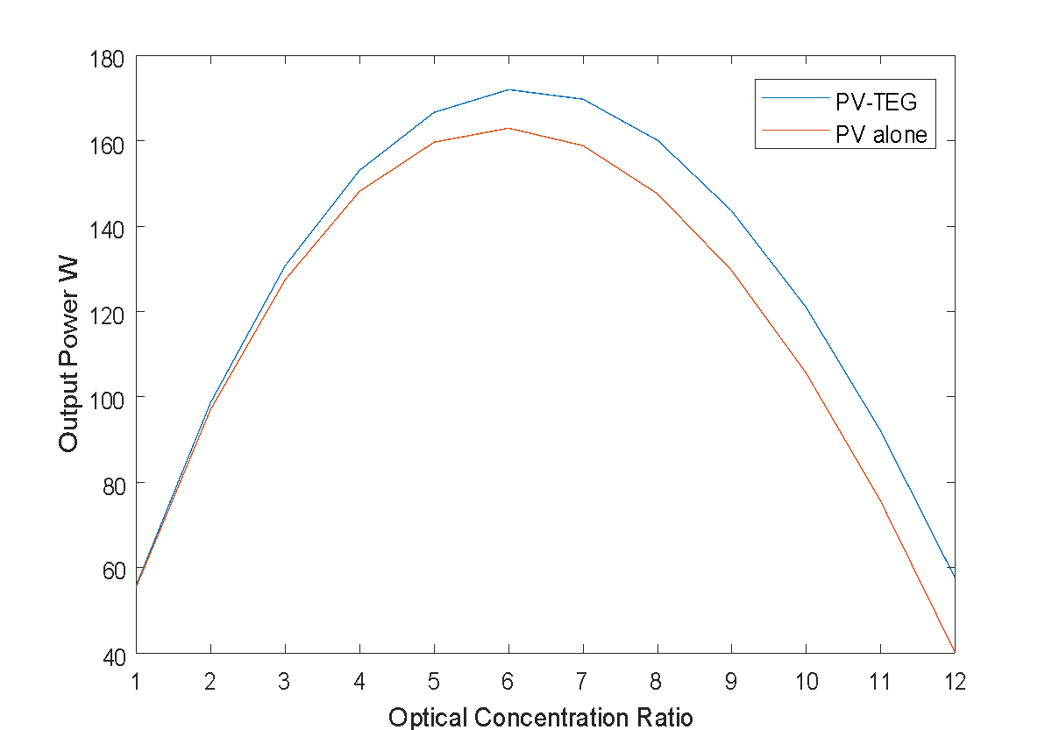

**Figure 2.** Output power of the PV and PV-TEG hybrid system with concentrator.

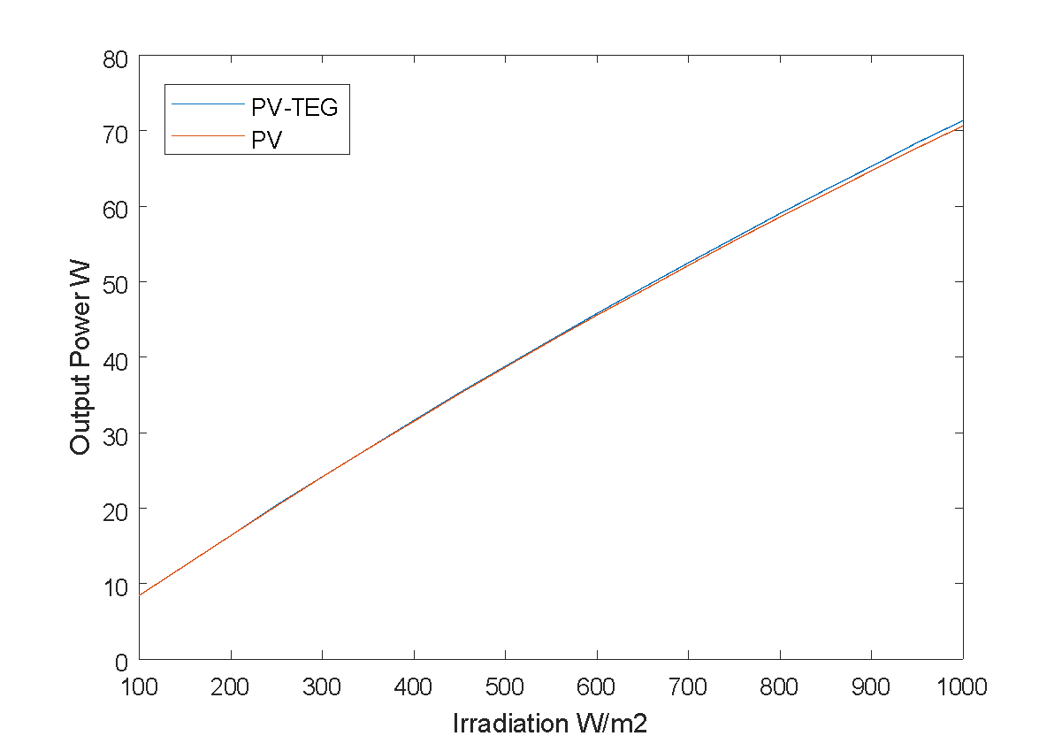

b

**Figure 3.** Output power of the PV and PV-TEG hybrid system without concentrator.

The results from Figure 2 and 3 showed that the contribution of the thermoelectric generator in the hybrid system with a solar concentrator is large compared to the hybrid system without solar concentrator which shows a small improvement. The power generated by the hybrid system with a solar concentrator is very large with respect to a photovoltaic panel. While the power of hybrid system without solar concentrator shows only a slight improvement. Results encourage the use of a solar concentrator in this hybrid system for better solar energy conversion.

# CONCLUSION

As the results shown, by integrating two different systems the photovoltaic system PV with the thermoelectric generator TEG to make a PV-TEG hybrid system, a better performance was obtained and encourages the use of this type of hybridization. The thermoelectric generator will convert by Seebeck effect the thermal energy produced by the photovoltaic panel which will add additional electrical power to the overall power. Results also showed that the contribution of the thermoelectric generator in the hybrid system with solar concentrator is large compared to the hybrid system without solar concentrator which shows a small improvement.

# References

1. A. Makki, S. Omer, H. Sabir, Advancements in hybrid photovoltaic systems for enhanced solar cells performance, Renew. Sustain. Energy Rev. 41 (Jan. 2015) 658-684.
2. Nicholas Gilmore, Victoria Timchenko, Chris Menictas, Microchannel cooling of concentrator photovoltaics: A review, Renewable and Sustainable Energy Reviews 90 (2018) 1041–1059.
3. Jin Zhang, Yimin Xuan, An integrated design of the photovoltaic-thermoelectric hybrid system, Solar Energy 177 (2019) 293–298.
4. Van Sark WGJHM. Feasibility of photovoltaic–thermoelectric hybrid modules. Appl Energy 2011;88: 2785-2790.
5. Jian L, Liao T, Lin B. Performance analysis and load matching of a photovoltaic– thermoelectric hybrid system. Energy Convers Manage 2015;105:891–899.
6. H. Nowak, The sky temperature in net radiant heat loss calculations from lowsloped roofs, Infrared Phys. 29 (1989) 231-232.
7. A.I. Kudish, E.G. Evseev, G. Walter, T. Leukefeld, Simulation study of a solar collector with a selectively coated polymeric double walled absorber plate, Energy Conversion and Management 43 (2002) 651–671.
8. A. Bejan, A.D. Kraus, Heat Transfer Handbook. Wiley-IEEE, 2003.
9. Ravita L, S.C. Kaushik, Modeling and performance analysis of a concentrated photovoltaic-thermoelectric hybrid power generation system, Energy Conversion and Management 115 (2016) 288–298.
10. C. Schwingshackla, M. Petitt, J.E. Wagner, G. Belluardo, D. Moser, M. Castelli, M. Zebisch and A. Tetzlaff Wind effect on PV module temperature: Analysis of different techniques for an accurate estimation, Energy Procedia 40 (2013) 77 – 86.